Marketing is the engine that drives commerce. At its core, it's about understanding what people want and need, and then crafting messages and experiences that convince them a particular product or service is the answer. This can involve traditional methods like television commercials and print ads, but also extends to the digital world through social media campaigns, search engine optimization, and influencer marketing.

Effective marketing goes beyond just promotion. It's about building relationships with potential customers. By providing valuable content, engaging in conversations, and fostering a sense of community, marketers can turn strangers into loyal brand advocates. This two-way communication allows companies to constantly refine their offerings to better meet the evolving needs of their audience.

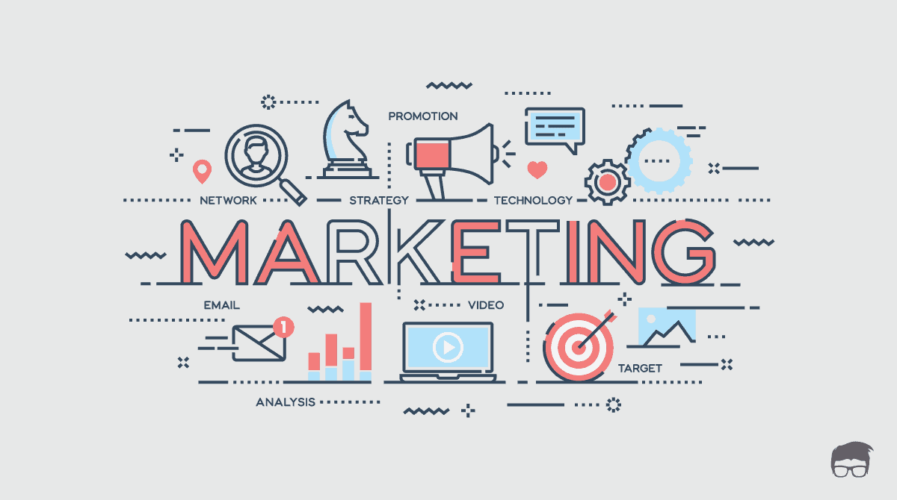

The marketing landscape is constantly evolving. New technologies and consumer behaviors emerge all the time. Successful marketers are those who can adapt and innovate. They embrace data analytics to measure the effectiveness of their campaigns and identify new opportunities. They stay on top of trends to ensure their messaging resonates with their target audience. In short, marketing is a dynamic field that requires creativity, strategic thinking, and a willingness to learn.